
Company
Logotype

Cone Beam Computed Tomography- Report



Porur Dental X-rays & CBCT

Patient Name : Mrs. Jaimol Joseph | Date of Report : 07.11.2024
Age/ Gender : 39 years/ Male | Region of Interest : CBCT Sectional Mandible
Referring doctor: Dr. Durga Swarnamugi | Indication : Bony protruberance in relation to 46, 47.
Clinical Notes: Nil
PATIENT INFORMATION

CBCT- Sectional Mandible provided
CBCT – IMAGE DETAILS

RADIOGRAPHIC INTERPRETATION

- In relation to the lingual aspect of 46, presence of a dome shaped bony area of protrusion that appears to extend posteriorly upto the lingual aspect of 47. The bone density within the bony protrusion appears to be similar to the adjacent alveolar bone -D2 pattern (reference is given in last page).
- Presence of a similar dome shaped protrusion evident lingual to 44 is evident, that has more hyperdense area within it.
- The alveolar bone in relation to the mandibular ridge is present with normal trabecular pattern.
- The tooth 46 is present with hyperdense restorative material involving the pulp chamber extending upto the apical third of the roots.

RADIOGRAPHIC IMPRESSION

- Bony exostoses in relation to lingual aspect of 44, 46, 47.

Kindly correlate with clinical findings


IMAGES FOR REFERENCE

RECONSTRUCTIVE PANORAMIC VIEW

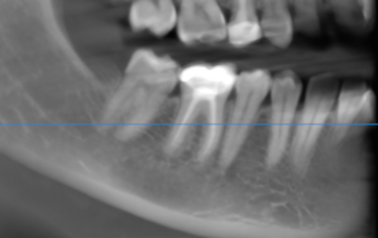

3-DIMENSIONAL VIEW

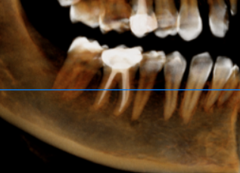

CROSS SECTIONAL VIEW

44 region | 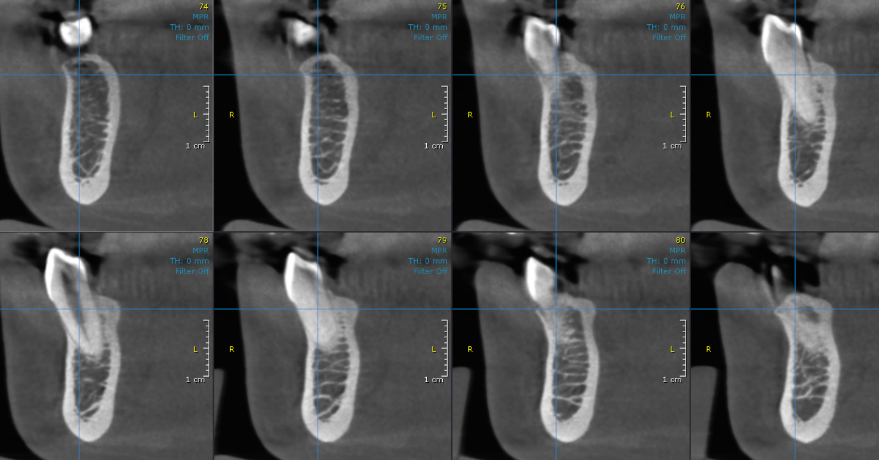
45, 46, 47 region | 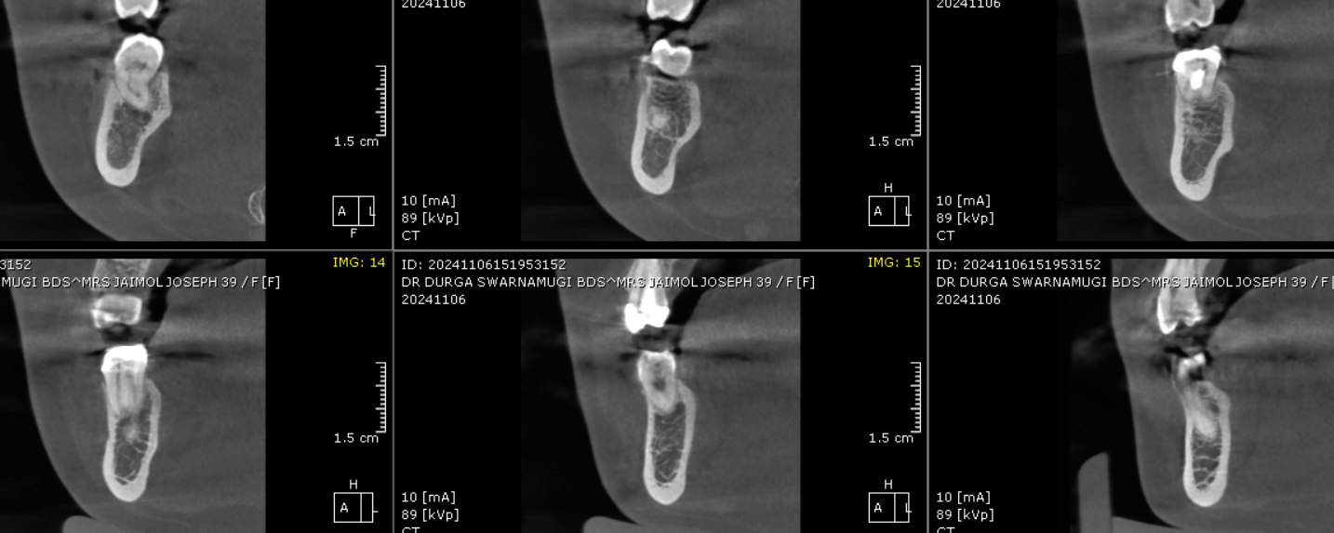

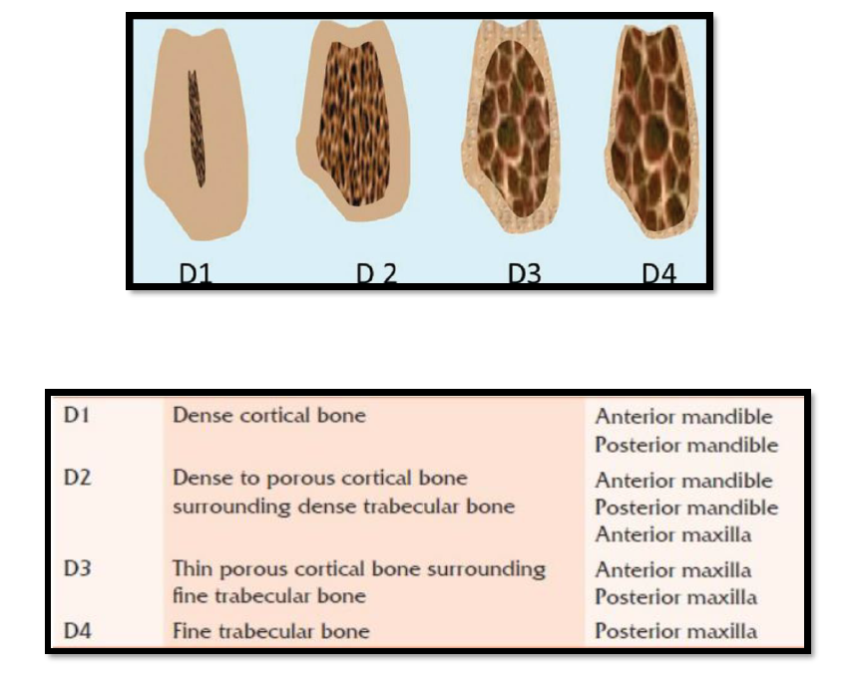
Reference

**** End of report ****

